EEC 134 Application Note
PCB Design
Kent Tanita

Table of Contents:
- Introduction
- Component Selection
- Schematic Design
- PCB Design
- Tapered Waveguides in KiCad
- PCB Fabrication

1) Introduction: In this application note, I will attempt to discuss the key design process our group took to design and fabricate the PCB.
2) Component Selection:
When selecting components, there are an overwhelming amount of places to view and purchase components. To minimize the time spent looking for the components, our group chose to use primarily Digi-Key Electronics to find components. Digi-key’s large selection and easy to use searching tools makes it a prime candidate for the initial search for ideal components.
Digi-key’s search function is made so it is extremely easy to use and filter the search to fit exactly the user’s needs. Using this function, almost every aspect of a component can be filtered. To highlight the granularity of the search function, shown below are the available filters for Digikey’s VCOs.
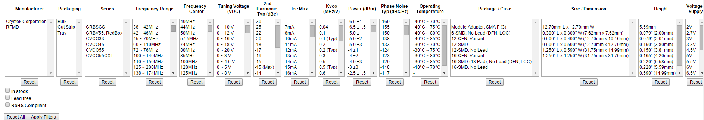
Using these different filters, it is very easy to find the exact fit for the board. Key filters in almost every component of this board are voltage supply, frequency range, packaging type, etc. Once a component is selected, there is a page highlighting the key components of the component. This is another key feature of Digi-key, which allows the user to see the component specifications without have to read through a datasheet. Shown below is said summary:
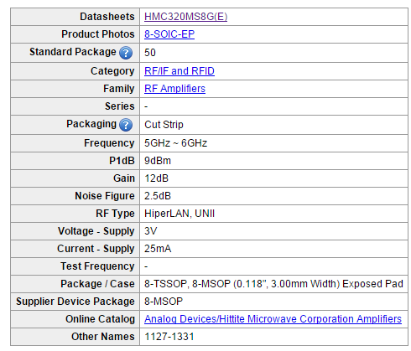
It is important to note that Digi-key is a distributor, not a manufacturer. This means that Digi-key will not provide free samples, so it is a good idea to visit other websites to see if there are similar or the same components and see if they offer sampling on their components. Four other companies our group used besides Digi-key for components are Maxim Integrated, Analog Devices, Minicircuits, and Hittite, all of which offered their components for free. Minicircuits requires contact with HR to obtain samples, while Maxim, Analog Devices and Hittite both have an automated system for samples.
3) Schematic Design:
In circuit design, it is crucial to include bypass capacitors when supplying voltage. A decoupling capacitor is used to connect the voltage source to ground to allow any fluctuations within the voltage supply to be bypassed to ground. Fluctuations in the voltage supply could cause an unwanted time-varying response in the output signal. The exact type and values of the capacitors are usually in the datasheets. However, there was no such mention of bypass capacitors in Minicircuits VCO, but it is still a good idea to include them. Shown below is said layout:
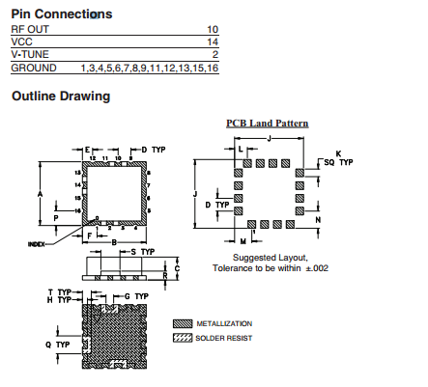
4) PCB Design:
The most crucial design aspect in the PCB design process is deciding the amount of layers your board would have. The two-layer and four-layer board are the most common option available. A four-layer board allows for a more flexible design—the ability to add vias going from layer to layer allows for a simpler, cleaner design. However, it is far more expensive to fabricate a four-layer board, so our group used the two-layer board for our design.
The two-layer board can be designed in many ways, but our group decided to separate the two boards into a high and low frequency board. We then used pin headers to stack the boards on top of eachother, as shown below. The two-layer board are particularly convenient for error-checking the fabricated boards. The leftmost picture is the RF board, the middle picture is the baseband board, and shown to the right is how the RF board is nested on top of the baseband board.
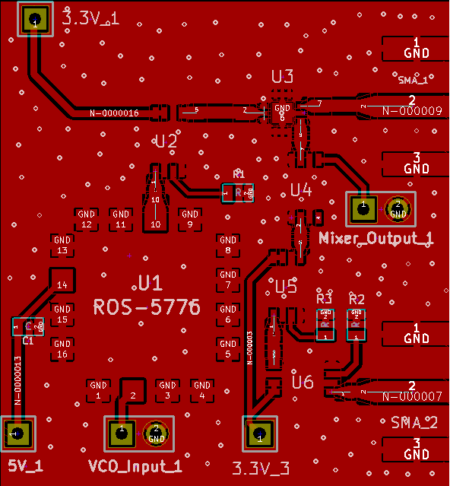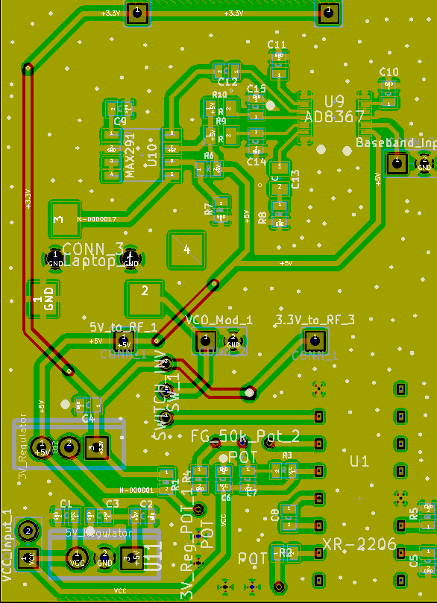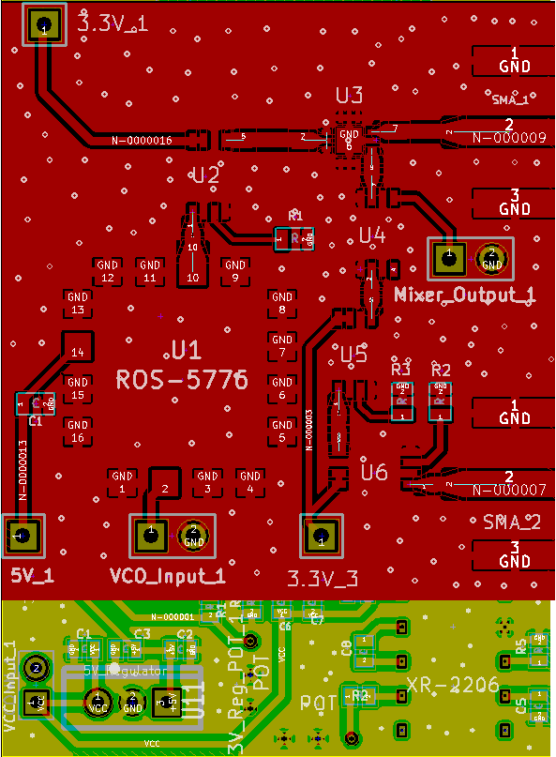
The material is also of particular importance when designing a PCB. In the case of our two-layer board, we chose to use FR-4, due to its cheap price. FR-4 is very lossy at higher frequencies, but this effect can be mitigated by lessening the length of every trace for the RF traces.
To implement a component onto the PCB, the footprint must first be designed. The footprint is the actual space that the component will be soldered onto. In KiCad, which is the PCB design tool that our group decided to use, there is a library with many footprints already included. However, it is not the most extensive library, so choosing a component based on the popularity of the footprint, or packaging, may be an efficient use of time. This information, again, can be easily seen on the datasheet, or Digi-key’s (and other similar website’s) filtering system. If a chosen component’s footprint is not available on KiCad’s library, that footprint must be made. A footprint is determined by the pad types, pad sizes, and pad separations. An example of one that our group made is shown below:
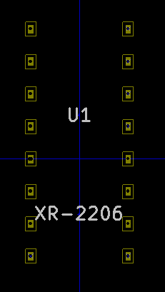
An option that is available when designing the PCB is to use evaluation boards. Evaluation boards are premade PCB’s that can be used for implementing a component. However, a fundamental weakness of evaluation boards is their size. Because an entire PCB and connectors have to be used for every component, evaluation boards present unnecessary weight, which is why our group did not use evaluation boards. Another weakness of evaluation boards is their price. However, this issue could be mitigated by the fact that hittite provides free samples of evaluation boards, with the additional benefit of the component already soldered on the evaluation board. Shown below is the evaluation board for the mixer that we chose to use, found at the bottom it the datasheet:
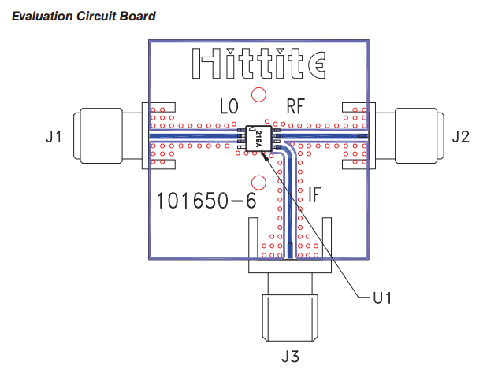
When actually designing a PCB, there are a few general considerations that were not mentioned earlier, that are helpful to keep in mind:
- Use thicker traces for lines that conduct higher current. This may not apply for waveguides.
- Avoid right angles for a PCB trace. This adds extra unwanted resistance. Use 45-degree angles instead.
- Add ground stitches, or vias, around your board to ensure that the ground planes on both layers are properly grounded to the same level.
5) Tapered Waveguides in KiCad:
When laying out the RF PCB, the traces become particularly important. Most components are matched to 50 a ohm load, which means that there will be reflection if the RF trace does not have a characteristic impedance of 50 ohms. This effect can be mitigated by shortening the length of the trace. However, due to the finite length of the trace, there will be loss, so trying to properly design the trace is an important consideration.
To design the trace, we used ADS’s LineCalc tool. The exact design parameters depend on the fabricated board’s specifications, which can be found on the distributors website. It is important to note that the length of the waveguide does not matter, if the trace is properly designed. The length of the trace does not affect its characteristic impedance, so that input into LineCalc is inconsequential. The trace, when implemented into the PCB, should be made as short as possible.
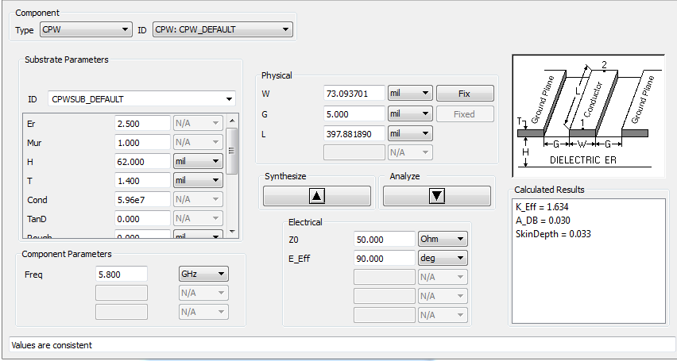
As seen above, the trace of choice was a coplanar waveguide. The coplanar waveguide utilizes the extra capacitance from the side conductors to increase the total capacitance, lowering the required width of the trace.
There is no built in function to implement waveguides into KiCad. The only way to do so is to change the width, length, and spacing of the trace to create the coplanar waveguide. However, KiCad does not allow any connection if the width of the trace is thicker than the pad width. To work around this, we must go use a tapered waveguide. This can be done in the footprint editor in KiCad. Shown below is the footprint for the LNA. However, pins 2, 7, and 9 must connect to an RF trace of substantially thicker width. The pad dimensions are 10 mil by 20 mil, while the trace thickness is 35.8 mil.
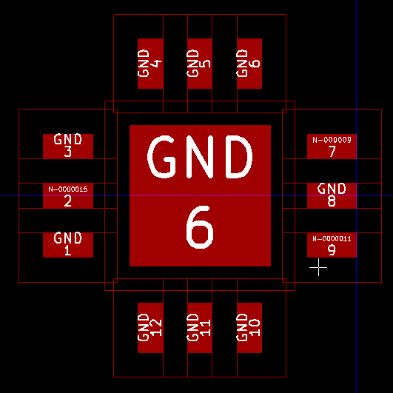
To work around this problem, first add trapezoidal pads that are perfectly touching the pads of interest. Ensure that they are both labeled as the same pad number.
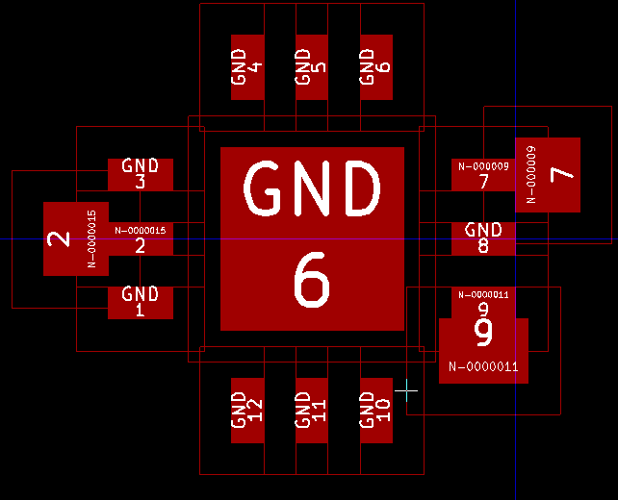
Next, go back to Pad Properties, and change the “Trap delta dim” in combination with the X and Y size to create the trapezoid of your choice. The delta dim property adds and subtracts the input delta value from two opposite sides. If they are the incorrect sides, change the “Trap. Direction” property from horizontal to vertical, or the orientation from 180 to -180, depending on the desired orientation. So, the size of the X/Y (depending on the orientation) added with the delta must add to the trace thickness, and the X/Y size subtracted with the delta must be the pad thickness. The size of X/Y should be the average of the trace and pad thickness.
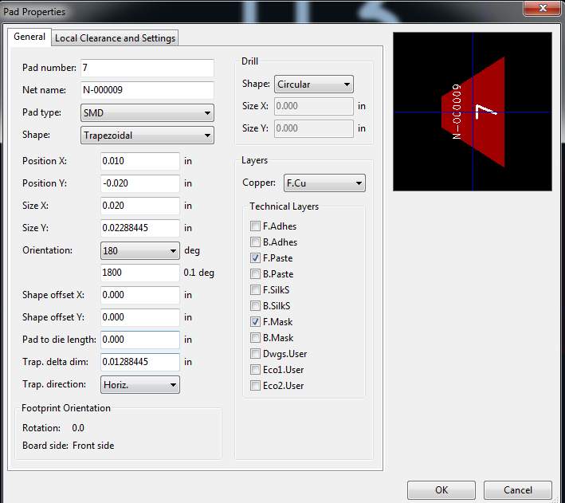
If done correctly, the pad should look like so:
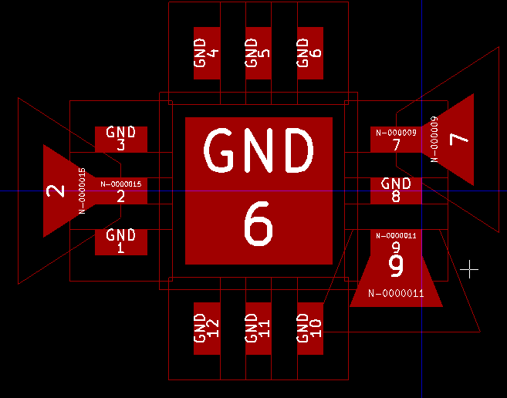
Now, simply add a rectangular pad of the same pad number to connect to the tapered pad and the rest of the waveguide.
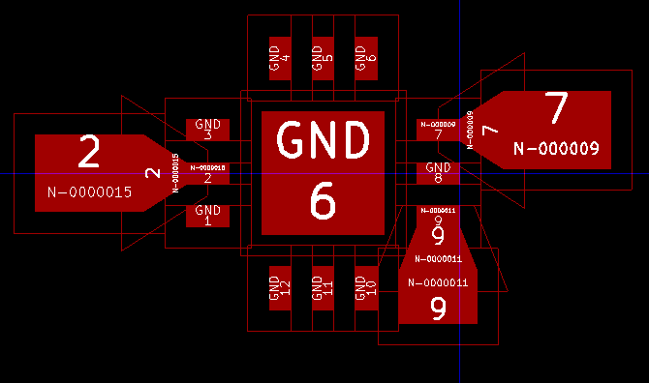
The LNA implemented within the layout:
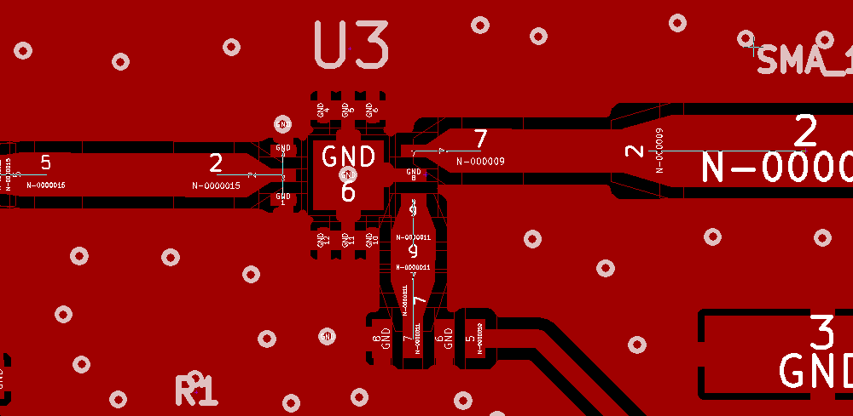
6) PCB Fabrication:
After the layout is complete, the board must be fabricated. There are many places that will fabricate the PCB, but our group had the option of Bay Area Circuits and Oshpark. They have different board specifications, turnaround time, and prices all of which can be found on their respective websites.
Oshpark does, however, have a particularly convenient and easy to use PCB render tool. By uploading a Gerber file onto Oshpark’s website, Oshpark can produce many different views of the fabricated PCB, ranging from an overall view, top and bottom solder masks, copper layer, solder masks, drills, and silk screens. Shown below is the overall top and bottom view on the left, and the solder mask and drill holes on the right. It should be noted, however, that this is the render is only an approximation – there is no guarantee that there will not be any discrepancies between the rendered and fabricated board. Also, your group can utilize this tool without actually using Oshpark to fabricate, and so this rendering process should be considered before sending your board out for fabrication.
