Printed Circuit Board Design
By Brad Welby
Engineering projects undergo many stages of development. First the product must be thought up, next you have to put together a theoretical design, the design should be computer simulated, and then the design is implemented onto a breadboard for initial testing. But an important part of any electrical engineering project is the conversion from breadboard to printed circuit board or PCB.
A printed circuit board is a realization of a breadboard, with solder pads to solder components to and copper trace acting as wires, connecting pads together. PCBs can be one or more layers of copper on a dielectric substrate. The purpose for using a PCB for the final implementation of a design is to reduce the size of the device, and make it less susceptible to issues. Because a PCB does not have looping wires it is much cleaner and easier to analyze and debug. Another advantage of the PCB is that once a design has been tested and proved working it is much easier to print more boards with the same design than it is to build multiple breadboard products. Typically PCBs are designed using specialized computer applications and then ordered from a PCB fabrication company that can process an electronic design.
Software Selection:
The first step in performing PCB design is to get the correct tool for the job. While there are dozens of different software out there for PCB design, for beginner level design there is no reason to pay for a “top of the line” product. The two free programs that I experimented with were KiCAD and EAGLE CAD. KiCAD was the first tool that I learned to use and it had a lot of promising features; mainly the abundance of hot keys for quickly performing tasks like moving and rotating objects. There are also a lot of useful tutorials and videos online that help to get a new PCB designer jump started into this new area of engineering tools. However KiCAD was flawed when it came to the library of parts. There were not very many “standard” parts and footprints available in KiCAD, which made the design process much more difficult. EAGLE CAD proved to be almost the opposite of KiCAD, with a more difficult and “click happy” interface but more parts in the library. This abundance of parts made it much easier to represent resistors, capacitors, and DIP chips, because I did not have to personally make the footprints. Similar to KiCAD, EAGLE has tutorials and helpful videos online for getting started with the program. The other upside of EAGLE was its acceptance by PCB manufacturers. Because EAGLE is such a popular program, some PCB manufacturers, including OSH Park, accept EAGLE files instead of making you convert to Gerber files. This increased the ease of ordering the boards and proved useful when we were in a time crunch to order. After exploring these two tools I determined that despite its user interface flaws EAGLE CAD is the better option for PCB design.
Component Footprint Design:
When designing your PCB the best place to start is with the footprint design. A footprint is the solder pad layout for a component. While most resistors, capacitors, and other basic and standard components have footprints in the EAGLE library to use, more specific components such as VCOs and op-amps do not. Even when a footprint can be found for one of these more specific components, it is dangerous to take the footprint as correct on faith. The better practice is to design them yourself. To do this you need to find the data sheet on the component you are going to use, and locate the land pattern. The land pattern tells you the dimensions of the pads and their spacing as can be seen in Figure 1. Often the size and spacing of the pads will be given as a center value with a certain manufacturing tolerance. It is ok to assume that the center value will be the correct value.
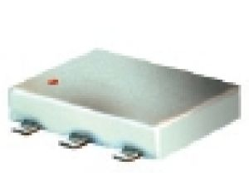
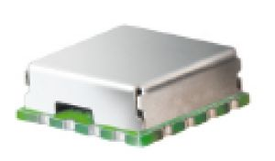
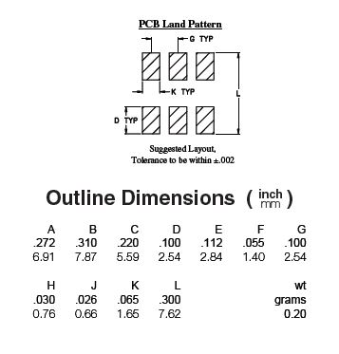
When designing the footprint there are some important things to look out for. First off be sure that the units you use are correct. Land patterns will often give dimensions in both mil and mm. Although a mil sounds the same as a mm, it is actually 1/1000th of an inch or 1 mil equals .0254 mm. Be sure that when you read the dimensions you read the dimensions that correspond to the grid settings in EAGLE. Another critical parameter to be on the lookout for is the orientation of the component in the land pattern. Sometimes they will be presented as if you are looking down from the top of the component, while other times they give you the view looking at the bottom. It is important to make sure that you know which direction you are viewing it from so that the pin layout and numbering are correct. The last area to pay special attention to during the footprint design is how the connectors on a component are laid out. More specifically they can either be external (Figure 3), sticking out from the component, or internal (Figure 2), recessed underneath the component. Typically components have external connectors; however some will have recessed connectors which will cause problems if not planned for appropriately.
Figure 3: External Pins
Figure 2: Recessed/Internal Pins
Figure 1: Land Pattern
Schematic Design:
With the footprints for all components designed it is time to move on to the schematic design. The schematic design is simply connecting the components together in an easy to view setting. It is the schematic design where you assign which components should be connected to each other. In the schematic window these connections are typically made by laying “wires.” It is also at this stage where you have an opportunity to name and number your components. A good practice is to give all components titles that flow with the graphical information. An example would be to name resistors R1, R2, R3, etc. The schematic view is merely the framework for the actual PCB design that occurs in the next step. However it is important to be neat and organized during this portion. Although it does not seem like a difficult or confusing step, when you are designing large and complicated system neatness goes a long way when it comes time to debug an issue. An important thing to note is that when you form a junction with two wires the program does not automatically recognize it as a junction. The junction tool allows you to drop a dot where you need to place a junction. Something else to keep in mind while designing your schematic is naming your pins. If you name pins the same thing then the program will recognize them as being connected, which cuts back on the number of wires you have and possible confusion. Once you have completed the schematic for your design it is time to generate the layout.
Layout Design:
The layout editor is where the actual PCB design occurs. When you first generate the layout all of the components will be to the left of the white box. This white box is your “board” and all of your components must be fit into it. However the box can be increased or decreased in size as needed. When designing your first PCB it is likely that you will be doing a simple low frequency, two layer PCB. While placing your components on the board it is important to keep in mind the space being occupied. The larger the area the more expensive the PCB is going to be. Also as you get to more complex designs, with the intention of sale to the public, smaller is almost always better. After dragging all your components onto the board and laying them out appropriately it is time to connect them. Although many PCB software programs have auto-connecting tools to run the traces for you, this is not recommended. Most of the time these tools cannot get everything connected, and they do not perform the layout in the most efficient manner.
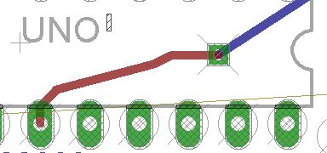
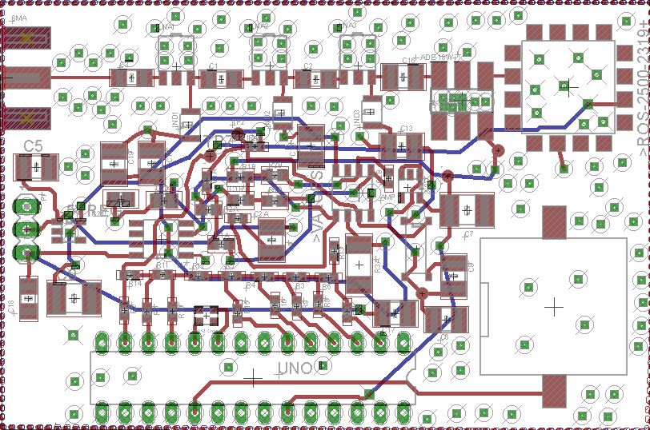
When performing the layout for these baseband components there are multiple things to keep in mind. When laying your traces you should be sure to avoid any angles sharper than 90 degrees. These angles are often difficult to be fabricated by etching techniques and will result in a flawed board from the factory. Another thing to keep in mind is the location of the power supply. In order to shorten trace length you want the power supply to be as close to all active components as possible. The reason for this has to do with power. There will be some inherent resistance in the traces which is proportional to their length. Therefore the longer the trace, the more resistance, thus the more power dissipated due to P=I²*R. The width of the trace also plays a role in the resistance, and therefore it is good practice to make the power lines wider than other traces on the board. A good starting width for these traces is 24 mil. Power supply location is also important because of accessibility. It is important to design all PCBs with the intention of the device being used by a consumer. Because of this it is better to have the power supply on the edge of the PCB so that a user could change the batteries when necessary without having to see or touch anything on the PCB. Bypass capacitors, from the power supply to ground are also helpful to eliminate noise and prevent possible oscillation in your op-amps. These bypass capacitors should be place immediately next to the power supply for optimum affect. While running traces you will inevitably find that you cannot make all connections on one layer of the board without having them cross paths and even if you can by running a long ways around the board, it is a bad practice due to noise and losses. To overcome this issue on a two layer board you can use a via to connect to the bottom layer and run some traces on this lower level as seen in figure 4. Ideally the bottom layer will be solely used for ground, however this is not realistic. The best practice is to run as many lines as possible on the top layer, and only drop to the bottom layer when absolutely necessary. Finally for the design of the two layer baseband board you should flood both the top and bottom with a ground plane, and connect the two planes with numerous vias. This provides a large ground plane which can help to improve the results. An example can be seen in Figure 5.
Figure 4: Bottom Layer Trace
High Frequency Layout Design
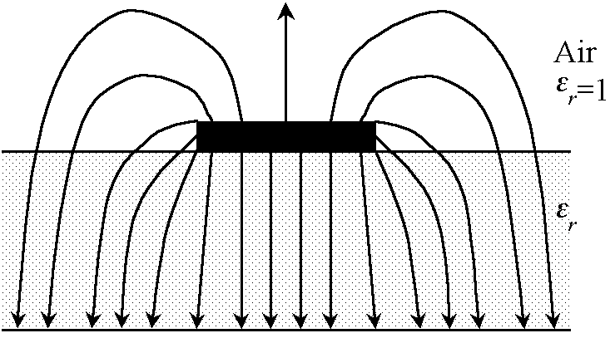
When designing a PCB with RF components additional rules and guidelines must be taken into consideration. Because RF signals have such small wavelengths, making signal traces turn can be difficult. This is because if the turn is too sharp the current traveling on the outside of the trace may end up 180 degrees out of phase; effectively canceling the signal. In order to avoid this issue all RF traces should be straight with no turns. However if this is not doable, gradual, miter edged angles should be used. When operating at RF frequencies simple copper traces are no longer a viable option for conducting the signal. Instead 50 ohm micro strip transmission line must be used. Obtaining 50 ohm micro strip line is dependent on the width of the traces. Using the frequency of operation, the substrate dielectric constant, the distance between the trace and the ground plane, and the height of the copper layer obtained from the manufacturer’s website you can determine the necessary width. Ideally this width is around 10 mil. This is easiest to do using Agilent’s ADS or an online calculator. However when doing this with a two layer board it is likely that the required width will be too big to be practically realized. Therefore it is recommended to switch up to a four layer board. This reduces the distance between the trace and the ground plane, and brings the trace width back down to a reasonable size. I will explain more about four layer boards later.
Figure 5: Vias on PCB Connection Ground Planes
Figure 6: Electromagnetic Radiation from Microstrip Line
Another issue to be aware of with RF PCB design is where you run your traces. As can be seen in Figure 6 RF signals do not merely travel on the microstrip lines, the travel on top of the lines and are constantly radiating outward. Because of this it is important to keep all baseband traces separate from RF in order to reduce noise on the baseband lines. After all RF traces have been laid the next step is to isolate the lines from the rest of the circuit as much as possible. To do this place vias on both sides of the microstrip going to ground. This helps to keep the electromagnetic fields contained.
As mentioned above, it is recommended to use a four layer board when designing a PCB with RF elements. A typical layout for a four layer board is to have the top layer be components and your main traces. The second layer should be your ground layer. This allows for the best RF transmission lines because of the short distance between the two layers and the lack of any impeding elements. Another way to improve the performance of your design and reduce noise is to mostly separate the ground plane of the RF section from the ground plane of the baseband section. These planes should be completely separated with the exception of a small connection. If there is any unwanted noise on one of the planes, this will keep it from affecting the other section of the board. The third layer should be your power plane. By having a power plane you eliminate the issue described above of needing to have larger trace widths and short lines. Finally your fourth or bottom layer will be another layer for running traces. As with the two layer board, once all traces have been laid the top and bottom layers should be flooded with ground and vias placed to connect all of the grounds together.
Lastly, after finishing the design it is important to check to make sure that parameters such as minimum trace width, minimum clearance, minimum separation, etc. are within the dimensions given by the manufacturer. Most manufacturers will post their minimum design specs on their website. Take these values and enter them into the design rules check. Then run the check. If there are any errors it is important to fix them before placing an order. The exception is the stop mask error. EAGLE often gives an error called “stop mask.” Stop mask error occurs when the silk screen and the text are overlapping. While this can be fixed, manufactures will automatically clip the text if it impedes upon any of the important materials. Because of this the error may be disregarded.
At this point the PCB should be complete and ready to order if submitting your EAGLE file. If the manufacturer does not accept EAGLE files then it must be converted to a Gerber file. When you receive your PCB it is important to check and ensure that everything was manufactured correctly. This mostly entails performing a conductivity test between important points.
This document should be useful in the design and implementation of a PCB; however it is not a tutorial to using EAGLE. I recommend that a beginner to PCB design use this application note to help supplement knowledge gained from online tutorials which go more in depth into the actual usage of the program. Some good EAGLE tutorial links are given below.

http://www.ece.ualberta.ca/~ee401/resource/manuals/Eagle02.pdf
http://www.youtube.com/watch?v=1AXwjZoyNno
http://www.youtube.com/watch?v=CCTs0mNXY24

